Kol Simcha Torah Gazette
For parshas behalosecha 5786
Vol 10 Issue 34 (Whole #499) 21 Iyar 5786/ June 6, 2026
Printed L’illuy nishmas Nechama bas R’ Noach, a”h
For a free subscription, please forward your request to keren18@juno.com
Past emails can be found on the website ShabbosStories.com under Brooklyn Torah Gazette

The Legacy of Aaron the
High Priest for Every Jew
From the Teachings of the Lubavitcher Rebbe
Rabbi Menachem Mendel Schneerson, Zt”l
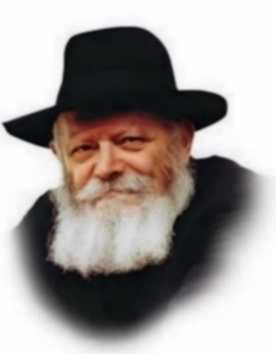
This week's Torah portion, Behaalot'cha, opens with the command to Aaron to kindle the lamps of the menora, the seven-branched candelabra that stood in the Sanctuary.

Aaron, whose duties as the High Priest are also described in Behaalot'cha, was known for his love of every creature. Hillel said of him, "Be of the disciples of Aaron, loving peace and pursuing peace, loving your fellow-creatures and drawing them near to the Torah."
What was so special about Aaron's way of life that we are enjoined to emulate it? Aaron did not wait for those who stood in darkness to come within the circle of light, but went out to them. He went, in Hillel's words, to his "fellow creatures," a word including those who had no other merit than that they too, were G-d's creations. Nonetheless, he "drew them near to the Torah," rather than drawing the Torah near to them. He did not simplify or compromise its commandments in order to bring it down to their level. Rather than lower the Torah, he raised people.

This facet of Aaron's life is suggested in this week's portion which opens with the command, "When you light (literally, 'raise up') the lamps, the seven lamps shall give light in front of the menora" (Numbers 8:2).

The lamps of the menora of the Sanctuary are a symbol of the Jewish soul - "The lamp of the L-rd is the soul of man." Aaron's task was to raise up every soul, to bring out the Divine within the Jew from its concealment in the subconscious.
The Sages sought an explanation for the fact that the word "raise up" (behaalot'cha) is used, instead of the more obvious "light" or "kindle." And they concluded that the verse meant that Aaron was to kindle them "until the flame rises up by itself."

Aaron's spiritual achievement was therefore not only to light the flame in the souls of the Jewish people, but to take them to the stage where they would give light of their own accord. He did not simply create disciples, people who were dependent on his inspiration. He engendered in them a love of G-d that they could sustain without his help.

This was Aaron's path, "loving peace and pursuing peace, loving his fellow creatures and drawing them near to Torah." And this must be the path of every Jew, lighting the dormant flame in the souls of Jews wherever they are to be found, preferring to be close than to be aloof, to be kind rather than severe, in bringing all our people nearer to Judaism.

Reprinted from the Parshat Behalosecha 5763/2003 (Issue #774) email of L’Chaim, a publication of the Lubavitch Youth Organization in Brooklyn, NY. Excerpted from Torah Studies by Jonathan Sacks, based on talks by the Lubavitcher Rebbe.

Rav Avigdor Miller on Why We Daven to Change Anything

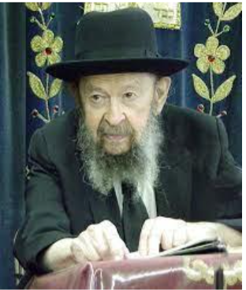

QUESTION: If Hashem always does what’s best for us, how does tefillah help m’mo nafshach? If what we’re mispalel for is good for us, Hashem should do it anyway. If it’s not good for us, Hashem won’t do it.
ANSWER: Question: What’s the sense of praying for Hashem to change our status? If He sent something upon us, it certainly is for our benefit?
So briefly it’s like this: When we pray, we say to Hakodosh Boruch Hu as follows. “Ribono Shel Olam, o Master of the World, we know why You sent upon us, this-and-this, let’s say a toothache or a headache. It’s because we ignored you all the time, when we didn’t have a toothache or didn’t have a headache, we should have thanked You all the time,” because it’s a miracle that you don’t have a headache.
The head is full of circuits and the smallest circuit gets confused, there’s a mistake in the routing of the electric messages, you get a headache. Small things can cause big headaches. Sometimes allergies disturb the function of the brain, the function of the nerves and they send messages of pain. So many causes. Why we don’t have headaches all the time is a miracle. Why we don’t have toothaches all the time is a miracle. And why do we forget Hashem during all these days and months that the things are working perfectly, He’s doing the miracle for us?
So, we say, “Hashem, we know the reason you sent us the headache today. It’s to remind us that you’re around.” So therefore, we say to Hakodosh Boruch Hu, “Now we acknowledge, we recognize that You’re around and from now on, if You’re going to heal us, we’re going to see to it that we’ll recognize You by thanking You constantly. That’s all You want. So why should we be aware of You by headaches? We’ll be aware of You by lack of headaches.”
So Hakodosh Boruch Hu says, “Well, if you really mean it, I’ll give you a try and let Me see if lack of headaches will cause you to thank Me as much as headaches will cause you to think about Me. Let Me see if lack of tzaros, if things go quietly and peacefully with you, when you’ll say, ‘ברוך אתה ה at the end of shemoneh esrei, המברך את עמו ישראל בשלום,” it’s peace. Peace means there’s no war. There’s no civil war, no invasions. Nobody’s gunning for you right now.
Once a man called me up late at night, an ex-yeshiva boy, he can’t leave the house because he borrowed a lot of money from loan sharks, gangsters. He was on narcotics, nebach and he couldn’t pay. It was 12:00 at night and he needed a few hundred dollars in emergency, otherwise he’ll be gunned down. What I did for him I can’t tell you. I didn’t do anything for him. But that fellow was in terror.
But tonight, when you go home, nobody’s gunning for you. That’s shalom. Are you thanking Hakodosh Boruch Hu? There’s so many reasons why there shouldn’t be shalom, so many bad people in the world. Nobody’s bothering you.
You know at night when you go to sleep, you leave your telephone on, it’s a miracle why it doesn’t ring in the middle of the night, a drunkard, is calling up Mamie… It happens rarely. Our telephones are silent during the night. Bums don’t pound on our door. Accidents could happen, they need an emergency telephone. They’d pound on your door, “Open up quickly, you have to save a life.” What could you do? Run down in your pajamas. And so, you live in peace. Do you appreciate peace? Are you thanking Hashem for peace?
So, if you do, you always are thinking of Hakodosh Boruch Hu, no toothache, ah, boruch Hashem. Get up in the morning, no headache, boruch Hashem! If you get up with a headache, thank You (Hashem) for my not having a toothache. There are worse things than headaches. Thank You (Hashem) for my not having arthritis. People ache in many bones. Thank You (Hashem) for a lot of other things.
And this fellow who is being pursued by the loan shark gang, if he could get up in the morning with a good headache but know that his pursuers are all gone, he wouldn’t mind the headache. He’d be singing. He’d be humming in the bathroom.
And so, Hakodosh Boruch Hu says to us, “If you are sincere, then I’ll see that you don’t have to be reminded by headaches, because you’ll remind yourself by lack of headaches.”
And that’s the purpose of praying. Praying means, we know that You want us to think about You, that’s why You send the trouble on us. We promise You that instead of that, we’ll thank You all the time. And so Hakodosh Boruch Hu is willing to take your word for it, and He’ll exchange one reminder for the other reminder.
(March 1981)

Reprinted from the current website of Toras Avigdor. The question was asked at Rav Avigdor Miller’s Thursday night lecture back in March 1981.

Thoughts that Count
for Our Parsha

And the men said to him, "We are defiled by the dead body of a man. Why should we be kept back?" (Num. 9:7)
We do not find in the Torah any other instance where a mitzva (commandment) that must be done at a specific time can be completed at a later date. Only the Passover sacrifice is permitted to be fulfilled one month later. Why is this case special? There were many Jews who tried or wanted to bring the sacrifice at the correct time but for various reasons could not. They pleaded not to be excluded. In the merit of their requests, a later date was given to them. The future Redemption will also come about in the same manner. If we will stubbornly do all in our mean to end our own exile, and beg and plead with G-d with all our heart and soul, the Redemption will come. (Rabbi Shlomo Cohen of Radomsk)

Have I conceived all these people? Have I given birth to them? (Num. 11:12)
Moses said to G-d: "I'm not the one who must suffer because of the Jews. You are responsible." A parent must share the suffering and distress of his children and have mercy on them, for good and for bad. (Rabbi Simcha Bunim)

This is the workmanship of the menora - beaten work of gold (Num. 8:4)
"Beaten work of gold," explains Rashi, means that the menora was to be made of a single piece of gold, beaten or pounded until it assumed the proper shape. Likewise, a person who desires to transform himself into a "menora," to kindle his G-dly spark and be illuminated with the light of Torah, should also do the same to himself - striking away at his negative qualities and working on his character until he, too, assumes the proper form. (Likutei Torah)

From the base, until the flowers, beaten work (Num. 8:4)
The base of the menora symbolizes the lowest level of Jews; the flowers, those on the highest spiritual plane. The Torah demands that the menora be made out of one piece of gold, just as the Jewish people is but one entity. Every Jew is incomplete by himself, without the rest of the Jewish nation, just as in the human body, the foot needs the head to function no less than the head requires the foot for mobility. (Likutei Torah)

The man Moses was very humble - more than any man on the face of the earth. (12:3)
Did Moses really not perceive his own special qualities? Because of his superiority over all other peoples, he was chosen by G-d that the Torah be given through him. However, Moses would say to himself: "If someone else had received all the great powers from Heaven that I did, he would certainly have achieved more and attained a higher level than I have. Another would have certainly used these great resources better than I." In this way, Moses considered himself lower than everyone else. (Sefer HaMaamarim)

Reprinted from the Parshat Behalosecha 5763/2003 (Issue #774) email of L’Chaim.

The Fascinating Tale of the Rebbe Doctor of Pietrekov
By Levik Gourarie

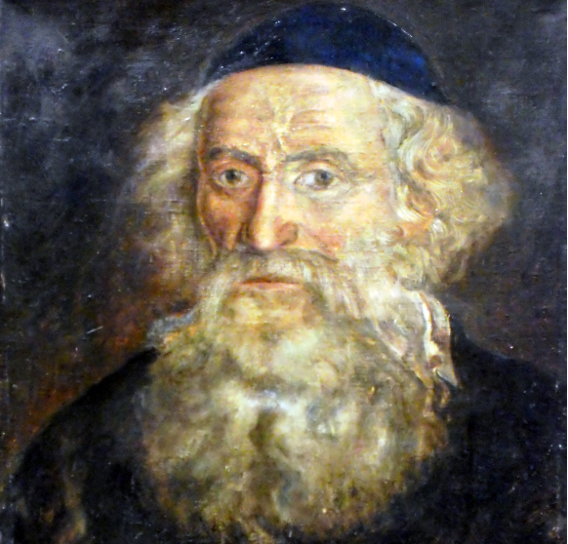
Rabbi Dr. Chaim Dovid Bernhard of
Pietrekov (1770s - 1858). Credits: GFDL

Teshuvah, “repentance,” is as old as time itself. From the time of the creation of the world, when G-d created the possibility of sin, G-d also gave us the ability to repent, or, better translated, "to return" to our original state of being—G-dly creations with G-dly aspirations. The returnee, the man or woman who has made this journey back home, is referred to as a baal(at) teshuvah, and serves as a great inspiration to each and every one of us.
Ever since the beginning of our history, many illustrious baalei teshuvah have not only rejoined the Jewish circle but have gone on to greatly contribute to Jewish life and thought. Starting with Ishmael, who grew up in Abraham's home only to leave it and then eventually return, through the famed Reish Lakish, the great sage of the Talmud who began as a wild and dangerous bandit, our history is filled with the tales of these great champions of teshuvah.
About 1500 years after Reish Lakish and his mentor (and friend and brother-in-Law) Rabbi Yochanan, we meet another fascinating duo, the great Rabbi Dr. Bernhard and the Rebbe of Lelov, Rabbi Dovid Biederman.¹

The Makings of Dr. Bernhard
Polish-born Dr. Chaim Dovid Bernhard served as the official doctor of Kaiser Friedrich Wilhelm the II, King of Prussia, and King Stanislaw August Poniatowski of Poland. He spent his youth studying in the great schools in Berlin, and then went on to study at the prominent University of Breslau (Wrocław) and the University of Erfurt. After serving as the official doctor of the Prussian military, he was brought to the royal palace to serve as the king's doctor.
The doctor was well-respected in the medical world. He was sought-after and corresponded with the greatest medical minds of his times, and he later went on to teach medicine at the University of Warsaw. He continued to serve as the doctor to many Polish nobles until the Polish uprising in November 1830.

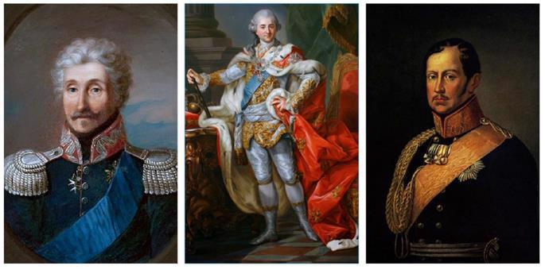
Left to right: General Józef Zajączek, Kaiser Friedrich Wilhelm the II, King of Prussia, and King Stanislaw August Poniatowski of Poland

But what may come as a surprise is that Dr. Chaim Dovid Bernhard had a devoutly religious upbringing in the small Polish town of Zhaloshin (Działoszyn). His life didn't play out quite the way anyone would've expected, making the arc of his life quite a fascinating one.
According to legend, Chaim Dovid was born sometime in the 1770s after his parents received a blessing from the famed Rabbi Elimelech of Lizhensk. As the story goes, the boy's father, Yissachar Ber, spent an exorbitant sum of money (more than he could afford) to help release a fellow Jew who had been imprisoned for failing to pay the unreasonable land use fees. Reb Elimelech, who arranged the negotiation and release, promised Yissachar Ber that G-d would bless him with a son whose radiance would shine across the whole world. A little while later, Chaim Dovid was born.
In his early teens, Chaim Dovid became ill and needed to be under medical supervision. While under the doctor’s care, his Torah study waned, and his interest and attraction to the secular world strengthened. Under the influence and urging of the doctor and his wife, who were "enlightened" Jews, young Chaim Dovid set off to Berlin, the Enlightenment capital of Europe, to study in the prestigious universities there.
It seemed as though Chaim Dovid had fallen into a fully secular lifestyle. He married Helena (Hadassah), a seamstress and tutor at the palace, and began raising a family. He moved back from Prussia to Poland, where he continued his medical work, while fraternizing with the Polish high society, making the most of the extravagant lifestyle he created for himself.

The Path to Teshuvah
But G-d had other plans, and by Divine Providence, the doctor came across the great Rabbi Dovid Biederman, the rebbe of Lelov. Known as Reb Dovid'l, he was renowned for his great love for others and his emphasis on seeking out lofty souls, including those that had “wandered.” His protégés included Rabbi Yaakov Yitzchok Rabinovitch ("The Holy Jew"), Rabbi Simcha Bunim of Peshischa and Rabbi Yitzchok of Varke. While there are many legends and versions of how these two great men met, we will share the most common one.
Yom Kippur. The shul in Lelov is packed; young and old of all types and stripes are there, pouring out their hearts to G-d on this spiritual day. Reb Dovid’l, their Rebbe, is leading them in prayer, his gentle yet passionate fervor uplifting them to the highest realms of devotion and connection with their Maker.
An unknown visitor arrives in Lelov. No one knows why he came; he may be passing through on his way back from visiting one of his high-profile patients, or it could be that his soul is drawing him to the Chassidic court in Lelov (Yom Kippur can do that to people). Whatever the reason, he is traveling through the Jewish neighborhood, when he hears shouts of "Doctor! Doctor!"
The visitor, Dr. Bernhard, runs to the rescue. A young woman is in labor, and things aren't going well. She is fighting with her last vestiges of strength to stay alive and save her unborn child. The doctor could not have come at a better time—he guides her through the birth, saving her and her child's life.
The young woman's father-in-law—who has arrived, frantic, at the scene—thanks the doctor profusely and invites him into his study to talk.
The father-in-law is the rebbe, Reb Dovid'l himself. They sit for a couple of hours on Yom Kippur, talking about life, purpose, Judaism and G-d. Reb Dovid'l finishes off their conversation with the words "Chaim Dovid! Return! You cannot imagine how much pleasure this will give your Father in heaven!"²
The switch is flicked. The doctor stays on in Lelov and begins to slowly make his way back to Judaism, guided ever so carefully by Reb Dovid'l. Chaim Dovid succeeds in turning his life around, growing every day in his service of G-d.

Rabbi Doctor
Reb Dovid'l brought Chaim Dovid to Lublin to meet his rebbe, Rabbi Yaakov Yitzchok Horowitz, the great Chozeh of Lublin (“Seer of Lublin”). Reportedly, the Chozeh struck a deal with him, saying, "You, Doctor, will heal my frail and weak body, and I will help heal your soul." So in addition to kings and noblemen, Chaim Dovid’s list of high-profile patients included the great rebbes of Poland.³
Following the advice of the Chozeh, Chaim Dovid continued working as a doctor, caring for his patients and teaching medicine.
However, he was now referred to not just as “Doctor,” but as “Rabbi Doctor.” He reduced his work hours and spent the rest of his time in study and prayer. When he was called to see a patient, he would recite Psalms on their behalf on the way over and would write "with the help of G-d" at the top of each prescription. He began to be known across Poland for his spirituality as well as his remarkable medical record.
At the request of General Józef Zajączek, he settled in Pietrekov (Piotrków). While he neither sought nor accepted the position of Rebbe, he did acquiesce to the requests of the masses and became a spiritual leader akin to the Polish rebbes of his era.⁴ He taught them Torah from his teachers and inspired them at the Friday night "tishes" (festive meals that featured spirited singing, Torah teaching, and storytelling).Independently wealthy, Reb Chaim Dovid gave tremendous sums of money to the poor and supported Torah study across Poland.
Rabbi Dr. Bernhardt formed deep and close relationships with all the great rebbes of Poland. The Rebbes of Lublin, Peshische, Lelov, Kotzk, Radomsk, Varke, Izhbetza, Kozhnitz, Strikov,⁵ Radoshitz, Gur, and Volbrash⁶ were all amongst his friends and confidants; they would consult with him not only on medical matters but rather on all aspects of Jewish life in Poland, specifically on those issues that would require a more broad and worldly vision.
He championed the Jewish community's rights and wellbeing. He had anti-Semitic doctors fired, he supported the Jewish community in the Holy Land and at home, and he built the famous shul in Pietrekov, even bringing in special architects and designers.
Even after his teshuvah, the wondrous Reb Chaim Dovid was not only loved by his fellow Jews, but by the gentiles as well; both the aristocrats and the peasantry had great respect and adoration for him. This painting was actually commissioned by a gentile doctor in Pietrekov who—coming from an anti-Semitic background—initially tried railing people against Reb Chaim Dovid. But after getting to know him a bit better, his erstwhile antagonist regretted what he had done, and as a show of remorse, commissioned a portrait of the great tzaddik.

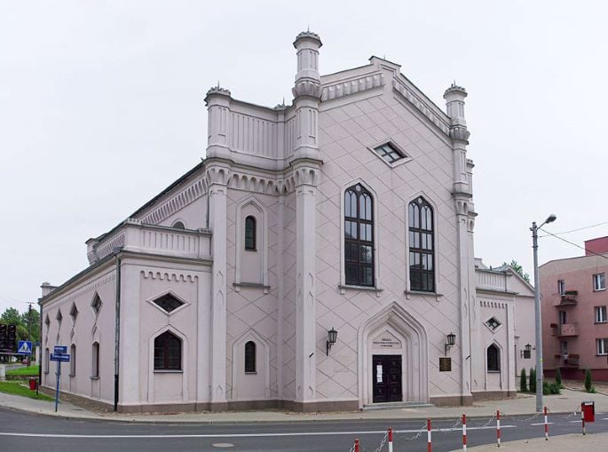
The great synagogue in Pietrekov. (Credits: Chrumps)

His Legacy
On the twentieth of Shevat, 5618 (1858), Reb Chaim Dovid returned his soul to his maker, leaving behind a wife,⁷ three children, and their families. He was buried in the old Jewish cemetery in Pietrekov, and an ohel (structure) was erected over his resting place a while later by a few Chassidim. The Nazis destroyed it, and it laid in ruins until 1992, when a generous Jewish family restored it.
"The Rebbe, Rabbi Chaim Dovid, Professor, Dr. Bernhard ztz"l." Perhaps these words inscribed on his tombstone, coupled with a brief entry in a Polish medical directory, can summarize the amazing life that he lived and the great impression he had on so many. The entry reads:
Bernhard, David, was born in Zhialozhyn in 1782. From 1805 he trained himself in medical sciences in Breslau. He was licensed as a doctor in Erfurt. He served for a while as the doctor of the Polish legions and afterward served in the study of "Physik" in Radomsk county. He lived in many cities in Poland, but for the most time he lived in Pietrekov, where he served as the doctor of the Jewish hospital. He died on Feb. 3, 1858. Bernhard was an observant Jew and devoutly Chassidic.
The journey of Reb Chaim Dovid served in some ways as a harbinger for the teshuvah movement that we have come to know, the reconciliation of a secular background with an intense Chassidic zeal and passion. Through combining these two contrasting forces, Reb Chaim Dovid imbued his career and worldly demeanor with a powerful and spirited connection to G-d. Not only was he not hampered by his secular past; he could reach broader audiences than his peers.
Bibliography: Baal Teshuva, by Yitzchok Arigor (Gur-Aryeh), Haifa, 1934.
HaAdmur Harofeh, by Aviezer Burshtein, Tel Aviv, 1970.
Chachmei Yisrael, by Dovid Halachmi, Israel, 1957.
Encyclopedia LeChassidut, by Dr. Yitzchok Alfasi and Dr. Yitzchok Refael, Jerusalem, 1986.
An entry in the Pietrekov Sefer Zikaron by Meir Shimon Gashuri, Tel Aviv, 1965.
MiPolin LeBerlin V’Chazarah, Netanel Yechieli, Mekor Rishon, 2006.
Footnotes
1. Note that many details of his life, as described in the sources cited below, parallel those of another doctor who attached himself to the Chassidic movement, Dr. Ahron Gordia, a disciple of the Maggid of Mezerich.
2. This line from Reb Dovid’l is found in almost all versions of the story of Reb Chaim Dovid’s return. In Chachmei Yisrael (Dovid Halachmi, Israel, 1957), it is recounted that Reb Dovid’l prayed and healed a patient that the doctor had already given up on. After checking his patient again, the doctor was amazed by this great rebbe. He traveled to Lelov to meet the rebbe, where the rebbe invited him in and spoke for a few hours, finishing off with, "Chaim Dovid! Return! You cannot imagine how much pleasure this will give your father in heaven!"
3. Rabbi Dr. Bernhard cared for the Chozeh during his final illness, after enduring a fall from a window following Hakafot on Simchat Torah, 1814.
4. His wife Hadassah became a great tzadeket in her own right. It was at her request that he never accepted the official position of Rebbe.
5. Rochel, Reb Chaim Dovid’s daughter, married the Rebbe of Strikov’s grandson. Her sister Hinda Leah stayed in Pietrekov as a midwife.
6. Yaakov Yitzchok, his son, actually became a chassid of Volbrash, and it was the Volbrasher chassidim that erected the ohel at his resting place.
7. His wife Hadassah had passed away in 1848. He remarried Rebbitzin Faiga Wiener, who survived him.

Reprinted from the archives of the Chabad.Org website.
What Israel’s Enemies
Don’t Want You to Know
By Sara Yoheved Rigler

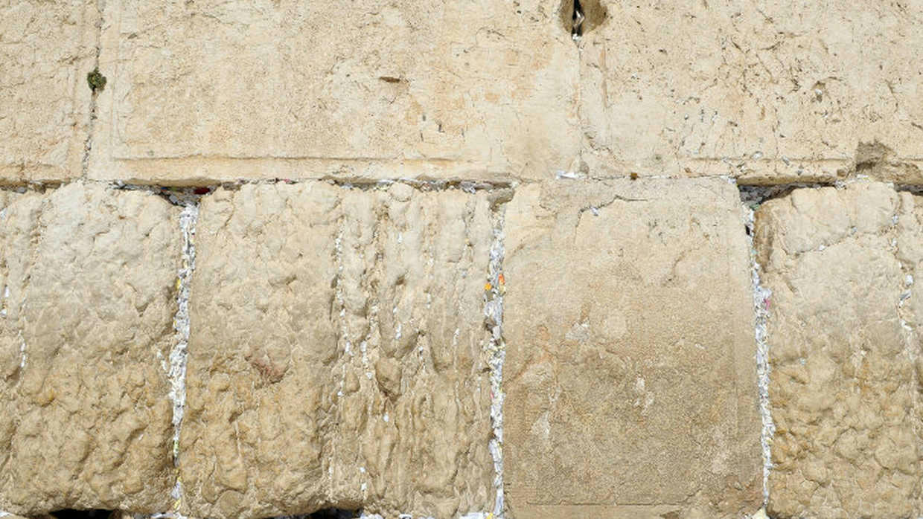

Some 20 years ago I was walking from my home in the Jewish Quarter of Jerusalem’s Old City to pray at the Kotel (the Western Wall), Judaism’s second holiest site, second only to the Temple Mount itself that towers above it. On the steps to the Kotel Plaza, I passed an Arab tour guide speaking in English to a large group of European tourists. Pointing toward the Golden Dome and the Al Aqsa Mosque on the Temple Mount, he said, “The Jews claim that their two temples stood on this spot, but there is no proof whatsoever to that claim.”
I was stunned. No proof? The gigantic, distinctive “Herodian stones” of the Western Wall itself, the remnant of the retaining wall King Herod built around the mountain when he enlarged the Second Temple, starting in 20 BCE, were incontrovertible proof. And what about the numerous contemporary historical descriptions of the Temple, including historian Josephus Flavius’s eye-witness account of the Temple, written in the first century CE?
Although an inveterate debater, I stood there unable to utter a word of rebuttal because I was shocked speechless by the boldfaced lie. It was as if an acknowledged scientist was telling his students that the world is flat.
Only recently, when reading Doron Spielman’s new book, When the Stones Speak, did I become aware that that Arab tour guide was just a small part of a widespread, carefully calculated campaign to deny the Jewish People’s historical claim to Jerusalem and the land of Israel.
The invective, “Colonialists!” being shouted against the Jewish State on university campuses and in European capitals is based on the allegation that European Jews came to Palestine in the late 19th and early 20th century as foreign occupiers. In the wake of the Holocaust, according to this view, the United Nations voted for a Jewish state, alongside an Arab state, in the small piece of land between the Mediterranean Sea and the Jordan River, in order to assuage their guilt. The implication of “colonialists” is that Jews have no more rights to that patch of land than the British had to India.
An inconvenient contradiction of that narrative is the Bible, which chronicles over a thousand years of Jews (then called “Israelites”) living in that patch of land. “The Bible should be put aside,” claimed Palestinian archaeologist, Hani Nur el-Din, professor of archaeology at Al-Quds University. “It’s not a history book.”
This statement, writes Doron Spielman, “was part of the broader, long-standing trend of denying Jewish history in Jerusalem that had persisted for decades.” In When the Stones Speak, he provides hair-raising evidence of this campaign.
(Even the name “Palestine” was an effort by the Roman Emperor Hadrian, after the Jewish revolt of 132-135 CE, to sever the historical identification between the Jews and their land, which had been called “Judea” for centuries. The term “Palestina” derives from the Philistines, one of the ancient Sea Peoples who had lived along the coast of Judea and disappeared from history with the Babylonian conquest seven centuries before the Romans exiled the Jews.)
If you can’t trust the Bible to legitimate the Jewish people’s historical claim to the land, then perhaps archeological discoveries in the City of David, the original Jerusalem which lies to the south of the walled Old City, can provide proof that Jews lived there in antiquity. When the Stones Speak is the riveting story of those archeological digs and what they revealed, as well as the opposition that tried to stop them.
The Crusade to Deny History
Excavating the City of David faced massive pushback from the Palestinian leadership and the European NGOs that support them. Sheikh Ikrima Sabri, the Mufti of the Temple Mount and one of the founders of Al Quds University, told a reporter for the German Die Welt in 2001, “There is not the smallest indication of the existence of a Jewish temple on this place in the past. In the whole city, there is not even a single stone indicating Jewish history…. It is the art of the Jews to deceive the world.”
Walid Awad, a Palestinian scholar in charge of publications for the Palestinian Ministry of Information, asserted in 1996: “The fact of the matter is that almost thirty years of excavations did not reveal anything Jewish.... Jerusalem is not a Jewish city, despite the biblical myth implanted in some minds.”
Even as recently as May, 2023, Mahmoud Abbas, the President of the Palestinian Authority, addressing the United Nations, claimed that there was no proof whatsoever of Jewish ties to the al-Aqsa compound [the Temple Mount]. He stated that Israel “dug under al-Aqsa. They dug everywhere and they could not find anything.”
When the Stones Speak tells of astonishing finds in the City of David that disprove the Palestinian lies. Dr. Eilat Mazar, a courageous and independent archeologist, using the Bible as her guide, discovered a monumental building, with walls 20 feet thick, which she maintained was the palace of King David and subsequent kings of Judea. She dated pottery she found within the ruins to the tenth century BCE, the time of King David.
Archeologists from Tel Aviv University, who had made a career of denying the Bible, jumped on Dr. Mazar and questioned the dating of her pottery shards. They argued that the massive building, clearly belonging to a ruler, was from two centuries before King David or three centuries after. In those years, only organic matter could be conclusively dated. An olive pit found deep in the structure was sent to the laboratories of Oxford University for Carbon-14 dating. After weeks of tumulteous debate in the media about Dr. Mazar's discovery, the results came back: the olive pit was from 1000 BCE, the period of King David.
Even more electrifying was her discovery of a clay seal that bore the name, written in paleo-Hebrew, of “Yehuchal the son of Shelemiah.” The Bible relates that the prophet Jeremiah, who lived in the 6th century BCE, prophesized that the mistreatment of orphans and widows would bring Divine judgment against the kingdom. Four of King Zedekiah’s officers told the king that Jeremiah was fomenting panic in Jerusalem. The Bible records the name of one of those officers: Yehuchal the son of Shelemiah.
The Pilgrimage Road
Even more gripping is the story of discovering and excavating “the Pilgrimage Road,” a 700-meter series of expertly chiselled limestone steps that led from the Siloam Pool, a giant ritual bath discovered at the southern tip of the City of David, directly to the Temple Mount. As Doron Spielman writes:
The road we had discovered wasn’t just a Pilgrimage Road; it was the Hag Pilgrimage Road used by the ancient Israelites who came to Jerusalem more than sixteen hundred years before Islam was founded.
This historical fact should have posed no challenge to Islam were it not for the Palestinian leadership. But they had been teaching an entire generation of their people the falsehood that there never was a Jewish Temple on the Temple Mount, and that the site was first sanctified by Muhammed…
With the discovery of King David’s Palace and the Pilgrimage Road, the City of David was transformed from a small backwater excavation into a leading archaeological site.
And with that transfomation came threats of violence against Israelis in general and against our workers, and even an attempted assassination.
I never expected a book on archeology to be a page-turner, but Doron Spielman is a master story-teller. As vice-president of the City of David for 20 years, he provides an eye-witness account of the drama and suspense of using archeology to prove that the Jews are the indigenous people of the tract of land between the Jordan River and the Mediterranean Sea. With a cast of colorful characters from Elie Weisel to Congresswoman Elise Stefanik, this is a must-read story.
As the author writes: “Grab almost any Israeli off the streets in Israel today and they will likely tell you: ‘We are here. We have always been here. And we’re not going anywhere else.’”
With the revelations narrated in this book, every Jew in the world should be able to vouch: The Jews have always been in the land of Israel. We are the indigenous people between the river and the sea.

Reprinted from the current website of aish.com

